What is ServiceNow

# Overview

Jeff Thies from ServiceNow Simple introduces ServiceNow by answering key questions about its purpose, platform, and infrastructure. ServiceNow is a cloud-based software company founded by Fred Luddy in 2003 to simplify IT service delivery, making it intuitive and efficient for business users. The video covers the company's employees, customers, history, platform functionality, applications, and global presence, concluding with a concise definition of ServiceNow.

# Introduction to the video and the main question: What is ServiceNow?

Jeff from ServiceNow Simple introduces the channel's mission to simplify ServiceNow concepts. The video aims to answer 'What is ServiceNow?' using a structured approach.

Jeff references a Rudyard Kipling poem to frame the discussion around six questions: Who, What, Where, When, Why, and How.

# History and milestones of ServiceNow.

Fred Luddy founded the company in 2003, initially named Glide Soft, which was rebranded to ServiceNow in 2006. The company went public in 2012 and was named the most innovative company by FORBES in 2018.

Bill McDermott became the CEO in 2019. The video transitions to the question of 'Why ServiceNow?

ServiceNow aims to provide a cloud-based IT department, simplifying interactions and making them more enjoyable.

# Overview of how ServiceNow works.

The NOW Platform is a cloud-based Application Platform as a Service (APaaS) that supports business IT needs with robust security, redundancy, and data backups.

The platform includes a comprehensive data model and the ability to create custom workflows and applications.

ServiceNow offers a wide range of pre-built applications categorized into IT, Employee, Customer, and Creator Workflows.

# Locations of ServiceNow’s offices and data centers.

ServiceNow is headquartered in Santa Clara, California, with offices worldwide. Its data centers are distributed globally to ensure redundancy and reliability.

ServiceNow Platform Overview

# Introduction to the ServiceNow platform user interface, covering its layout and common tools.

The ServiceNow user interface is a web-based tool essential for accessing the platform. This video covers the third lesson in the ServiceNow Fundamentals learning path.

The video will review common tools provided by the interface, including user menu, global search, chat, contextual help, system settings, application navigator, favourites, and history.

The presenter, Jeff, introduces himself and mentions the resources available in the video description. Viewers are encouraged to subscribe for notifications of new videos.

# Banner Frame: User Menu

Profile settings allow users to change personal information such as name, phone, date format, email, and time zone.

Impersonation feature is available for administrators or impersonators to view the system as another user, useful for troubleshooting.

System settings tool allows customization of the user interface, including general settings, theme, accessibility, menu settings, form settings, notifications, and developer settings.

# Application Navigator (Demo)

Further demonstration of the application navigator, including adding favorites and using the filter to find specific items.

Explanation of how the personal developer instance can be used to practice navigation and customization of the ServiceNow interface.

In-depth look at the three tabs: All Applications, Favorites, and History, and how to use them effectively.

The impersonation feature demonstrates how favorites and settings change when viewing as another user.

ServiceNow User Interface Overview

# Overview of the main screen elements of the ServiceNow user interface.

The lesson is divided into two main topics: an overview of the main screen elements and a deeper dive into the application navigator.

Three main screen elements: the banner frame at the top, the application navigator on the left, and the content frame in the remaining screen area.

Customization options and tools in the banner frame, including the user menu, global search, chat, contextual help, and system settings.

User menu options, including profile settings, impersonation, role elevation, and logout.

## Banner Frame: User Menu

Profile settings allow users to change personal information such as name, phone, date format, email, and timezone.

Impersonation feature is available for administrators or impersonators to view the system as another user, useful for troubleshooting.

Role elevation is a security mechanism for high-impact actions, requiring administrators to elevate their roles temporarily.

Logout option in the user menu to exit the ServiceNow instance.

## Banner Frame: System Settings

General settings include options to compress the UI, enable/disable keyboard shortcuts, and set the home page link

Theme settings allow users to change the color scheme of the interface, useful for distinguishing between different instances

Menu settings control the appearance of data lists and long text wrapping in columns.

Notification settings manage the types of notifications received and their delivery methods, while developer settings include options for application scopes and update sets.

## Main Screen Elements (Demo)

The application navigator is the main navigation tool on the left, with a filter at the top to find applications and modules quickly.

Three tabs in the application navigator: All Applications, Favorites, and History, allowing easy access to frequently used items and recently visited pages.

Applications and modules are organized hierarchically, with the ability to create separators for functional groupings.

ServiceNow Branding Overview

## Lesson 4 Overview and its importance.

Lesson 4 focuses on branding in ServiceNow and is brief but useful for understanding branding tasks.

The lesson includes a quick simulation to help viewers practice applying branding changes.

ServiceNow's guided setup wizards help in branding and customizing the platform's user interface.

The lesson also briefly discusses two other customization tools: ServiceNow Portal and UI Builder.

## Notes from Lesson 4 and their implications.

Branding in ServiceNow aims to make the user interface reflect your company's identity, increasing user comfort and adoption.

Guided setup wizards in ServiceNow help configure applications and modules, with some focused on branding.

There are two main guided setup categories: Service Management and IT Operations Management, each with specific setup tasks.

## Demonstration of applying branding in ServiceNow.

The presenter demonstrates logging into a personal developer instance to apply branding changes

The demonstration covers setting up overall instance branding to reflect the company's identity.

Guided setup is used to configure system settings and the welcome page to match company branding.

Details of configuring system settings and making branding changes, such as updating the header and browser tab title.

## Final configurations and summary of changes made.

Additional changes include updating the welcome page message, which is shown during user login.

The presenter marks the guided setup steps as complete, ensuring the changes are saved and implemented.

A summary of the lesson highlights the importance of branding in making the ServiceNow instance user-friendly.

ServiceNow Lists and Filters

## Introduction to ServiceNow lists and various types of lists available on the platform.

The video starts with an introduction to ServiceNow lists, including table lists, applicants, and incident lists. Jeff from It explains the importance of lists and their views in ServiceNow.

The List View UI is designed to present records from database tables, with tools for sorting, filtering, and analyzing data. Multiple ways to access lists are discussed, including using the application navigator and dot commands.

The List Control Menu allows users to choose from various saved list views, apply specific filters, and save custom views for easy access.

## Filtering and grouping data in ServiceNow lists.

Filter Conditions can be saved and applied to lists, allowing users to focus on records with specific attributes such as active status.

Grouping data by a single column, such as category, helps in organizing and viewing record counts per group. Users can easily remove groupings. Refreshing the list and adding it to favorites for quick access with applied settings.

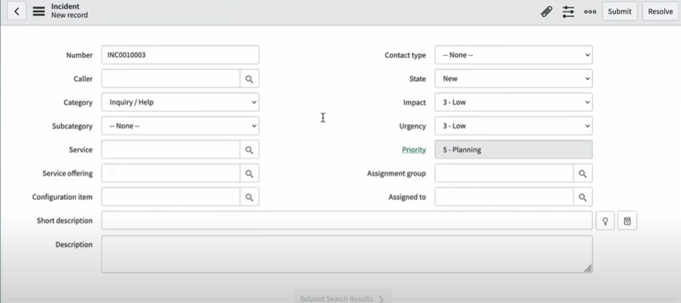

## Search tools and additional features in the List View interface.

The search tool allows users to find records by entering search terms for specific columns, with support for wildcard charactersThe Activity Stream Icon, available for tables that track activities, opens a sidebar with a chronological account of activities related to the list.

## Personalizing lists and managing list views.

The Personalized List Tool enables users to add, remove, and rearrange columns in the list view without affecting other users.

Additional list parameters can be customized, and changes are indicated by a dot on the gear icon. Users can reset to default settings if needed.

The Condition Builder is a powerful tool for applying filters with multiple columns, operators, and values. Saved filters can be reused.

## Column-specific search and use of breadcrumbs for filters.

The Column Search Row toggles search fields for each column, allowing for multi-column filtering with wildcard support.

Breadcrumbs in the list view indicate applied filters, helping users understand the current view context and easily modify filters.

Column labels and context menus offer additional options like sorting and configuring views, with some features reserved for specific roles.

## Advanced options and actions on selected rows.

Bar Chart and Pie Chart items allow for visual representation of data grouped by a specified column, accessible to users with the correct roles

List View provides extensive functionality through context menus, including row, column, and field-specific menus for various actions.

The Field Context Menu offers options like showing matching records or filtering out specific values, and copying URLs or system IDs for records.

Assigning tags to records helps in organizing and grouping related items for additional sorting, filtering, and notifications.

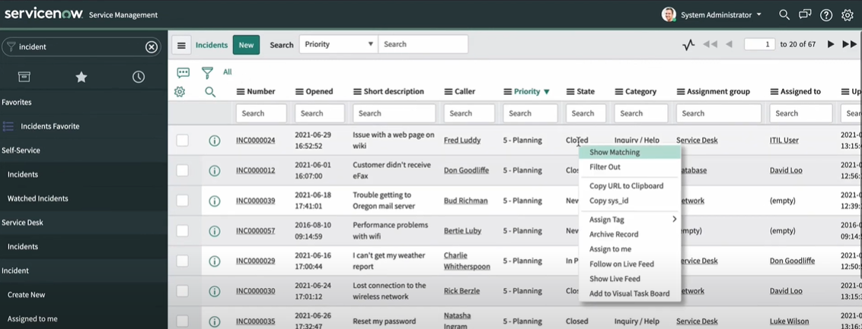

Forms in ServiceNow

* Forms are essential for viewing, changing, or adding data to records stored in ServiceNow's database.

It Demonstrates accessing a user record and creating a new record using forms. It Explains how forms are used to view or create records and mentions the variety of forms are available in ServiceNow.

## Types of form fields in ServiceNow.

##### String field

##### Choice field

##### Reference field

##### Boolean field

ServiceNow requires proactive saving of changes using submit, update, or save options.

Insert creates and saves a new record with copied values and closes the form, while insert & stay keeps the form open.

## Form sections in ServiceNow.

Forms are organized into sections to group fields and data, displayed in tabbed or collapsible formats.

Users can customize the display format through user preferences, affecting only the logged-in user's profile.

## Form views in ServiceNow.

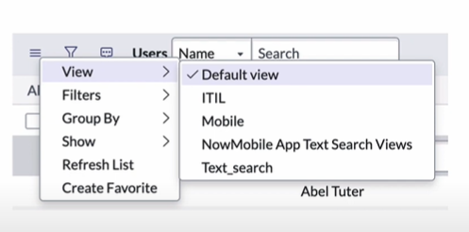

Different users may need different views of a record, which can be created and saved as form views.

Users can switch between form views using the view option in the context menu.

Demonstrates switching between different form views, like Business Card and Self-Service views.

Form views can be customized for different user types, with a default view set for each form.

Attachments can be added to records using the Manage Attachments button, useful for adding screenshots or documents.

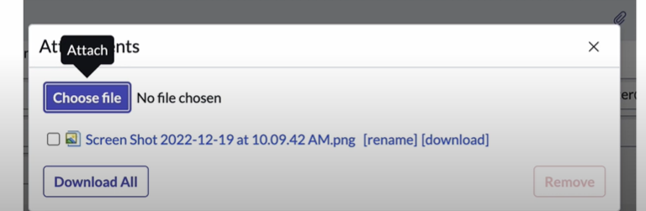

## Using form templates in ServiceNow.

Templates can be created by enabling the template bar and filling out the fields for automatic population.

Templates can set value of fields regardless of their visibility in the form view.

ServiceNow provides tools for creating and editing form views, accessible to users with certain roles.

Form Designer is a drag-and-drop tool for adding, moving, and removing fields and sections.